Spring Rest and Spring Data JPA

Goals | Demonstrate Spring's MVC framework  Integrate Spring and JPA
Time | 180 minutes

Version -1:

Develop a Spring Restfull Controller application to manage list of trainees by an admin. Refer the class diagram below to develop required classes.

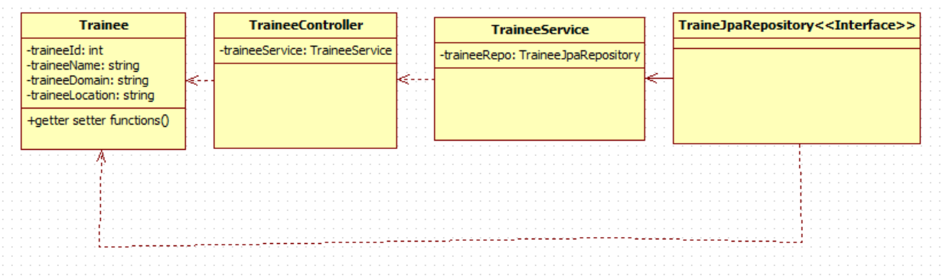

Class Diagram 5: Trainee related Classes
Note: Create DTO to exchange data
Write end point function in the controller as follows.
- List All Trainee
- List Trainee by Name
- List Trainee By Id
- Delete Trainee Ny Id
- Update Trainee Information in the table based on different criteria
- Insert Trainee

Refer below screen shot for reference
Note Do not Create UI here.
This UI will be created in Module 3
Test your Spring Resfull web service using Postman

